HW2

Kevin Lopez Sepulveda

Submission date: 07/17/2025 (11:59 PM)
- Revise the material in the class notes thoroughly before attempting the assignment.
- Please submit well commented code.
- Submitting a PDF explaining your code is highly encouraged.

You may use R/SciPy to find any quantiles instead of consulting the tables. If you do, clearly mention it in your answer script.
- Confidence Intervals. Recall the mean call duration example discussed in class. Suppose the company would like to estimate the average amount of time callers are on hold by computing a 95% confidence interval. As before, the population standard deviation of call hold times 𝜎𝜎 = 15 minutes. The company would like the width of the interval to be at most 1.0 minutes (on either side of the true mean). How many callers must they sample?
  - How many callers if an interval width of 1.25 minutes is enough instead?

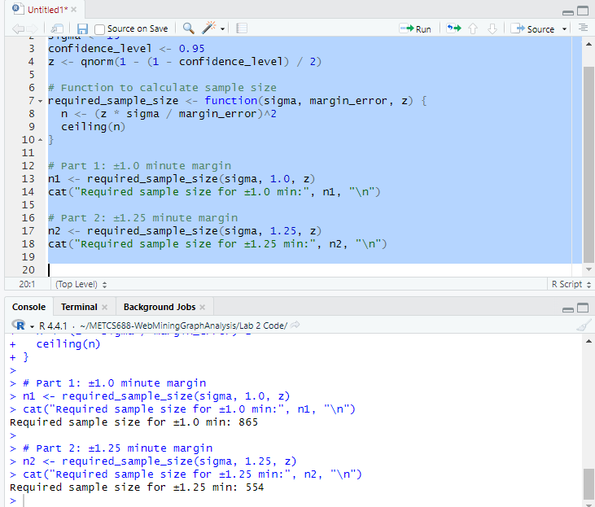
- More Confidence Intervals. The goal of this exercise is to generate random samples from an Exponential distribution (rate = 1, so true mean μ = 1 and variance σ² = 1). Using the Central Limit Theorem, construct approximate confidence intervals for the mean at three confidence levels. Evaluate empirically how well these intervals capture the true mean and illustrate the sampling distribution and the intervals.
- Generate 𝑀𝑀 = 10,000 groups of 𝑛𝑛 = 50 data points from this distribution. Hint: use rexp(rate = 1) and fix the seed for reproducibility (say set.seed(123)).
- Compute the vector of sample means 𝑋𝑋�1, ⋯ , 𝑋𝑋�𝑀𝑀. Plot either a histogram or a KDE plot of these

means. Using dnorm() overlay the density of
𝒩𝒩(1,
1)
𝑛𝑛
on this plot. What is the relation between the

distribution of the means and
𝒩𝒩(1,
¹)?
𝑛𝑛

- For each sample 𝑖𝑖 compute the confidence intervals defined by the end points

𝐶𝐶𝐼𝐼 (𝛼𝛼) = 𝑋𝑋�
± 𝑧𝑧
𝜎𝜎
,

𝑖𝑖
𝑖𝑖
^{𝛼𝛼} √𝑛𝑛

where the confidence level 𝛼𝛼 = 90%, 95%, and 99%. Hint use qnorm().
- For each 𝛼𝛼, calculate what fraction of the 𝑀𝑀 intervals contains the true mean 𝜇𝜇 = 1. Prepare a table of these recorded fractions alongside the nominal (expected) fractions.
- Visualize the intervals as follows for each confidence level, plot 50 confidence intervals as line segments. So, the 𝑥𝑥 − 𝑎𝑎𝑥𝑥𝑖𝑖𝑎𝑎 of this plot would be sample indices (50 samples), and the 𝑦𝑦 − 𝑎𝑎𝑥𝑥𝑖𝑖𝑎𝑎 would show a line segment corresponding to the confidence interval. Use different colors for intervals that contain 𝜇𝜇 = 1 and those that do not contain the true mean.

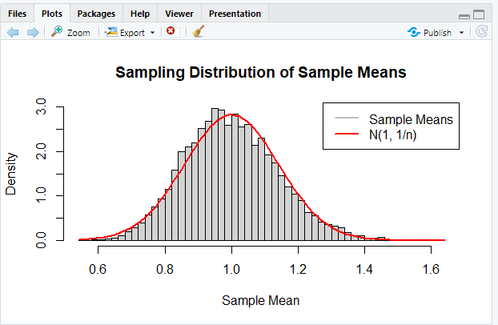
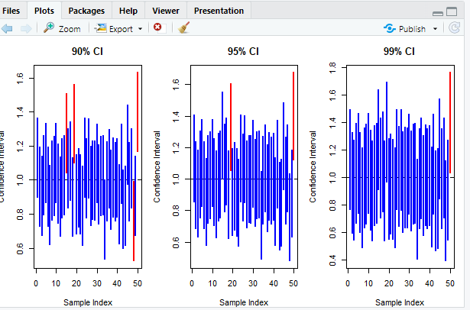

- Recall the four motivating examples for hypothesis testing discussed in Class 3. Classify the hypotheses therein (both null and alternative) as “simple” or “composite,” and mention which group of hypothesis tests (𝐻𝐻𝐻𝐻0, 𝐻𝐻𝐻𝐻1, ⋯ , 𝐻𝐻𝐻𝐻4) each of these examples belongs to.

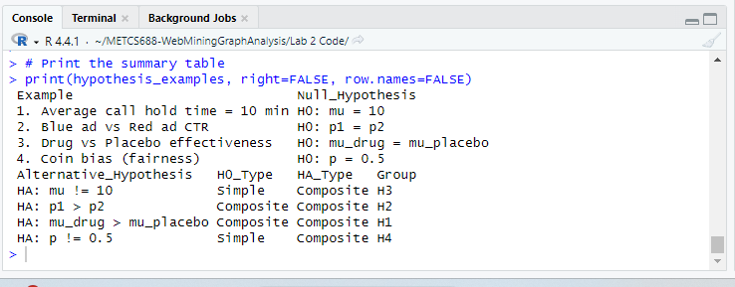

- Simple vs simple hypothesis tests. For the problems below, (1) state the most powerful test (not the final decision to reject/not reject ℋ₀, just the test), (2) compute the decision threshold, and (3) compute the power of the test. Assume 𝛼𝛼 = 0.05.

- A cereal maker advertises a net weight of 500 𝑔𝑔 (tolerance know, 𝜎𝜎² = 225𝑔𝑔²). You suspect the new filling machine actually is set to 505 𝑔𝑔.
  - 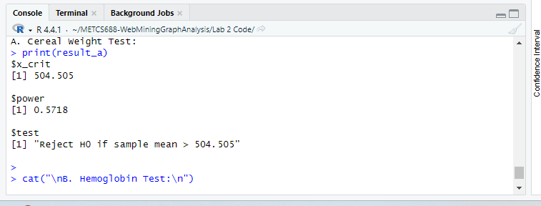
- A supplement is claimed to raise mean hemoglobin level from 13𝑔𝑔/𝑑𝑑𝑑𝑑 to 14 𝑔𝑔/𝑑𝑑𝑑𝑑. Hemoglobin level standard deviation in humans is known to be 1.5 𝑔𝑔/𝑑𝑑𝑑𝑑. Assume the trial had 145 volunteers.
  - 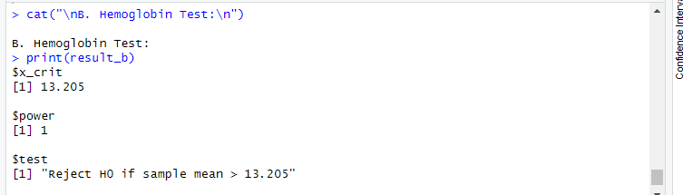
- Average spending per visit to a website is $80 (𝜎𝜎 = $20). Marketing estimates that a new loyalty scheme lifts it to $85. Assume that after launch, the decision was made based on 49 transactions.
  - 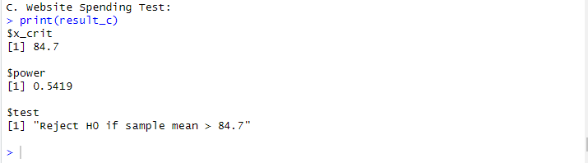

- One-sided Z-test. Write an R function simple_v_simple(sigma, n, mu0, mu1, alpha=0.5, X_bar) that takes 𝜎𝜎, 𝜇𝜇₀, 𝜇𝜇₁, 𝛼𝛼, 𝑋𝑋� and returns a list with (a) the reject/not reject decision,
(b) the decision threshold, and (c) the power of the test.
- Use your program to solve the following problem. Regulations cap mean lead concentration in river water to 10 𝑝𝑝𝑝𝑝𝑝𝑝 (parts per billion). An upstream factory may have raised the level in a river to
12 𝑝𝑝𝑝𝑝𝑝𝑝. Suppose you attempt to test your hypothesis using 16 samples with a known standard deviation of 4𝑝𝑝𝑝𝑝𝑝𝑝. Give all the outputs of your code for a measured mean level of 11.35 𝑝𝑝𝑝𝑝𝑝𝑝.
- Verify your answers using hand calculations.
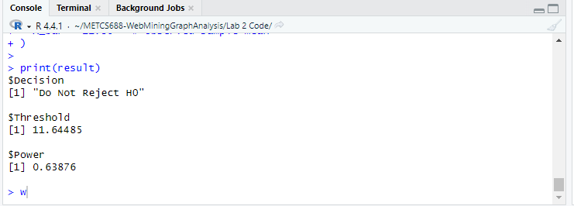
We are testing whether the mean lead concentration in river water has increased from 10 to 12 parts per billion using a one-sided Z-test. The null hypothesis is that the true mean is 10, and the alternative hypothesis is that the mean is 12. The standard deviation is 4, and the sample size is 16. The significance level alpha is 0.5, and the observed sample mean is 11.35.
First, we calculate the Z threshold (critical value) under the null hypothesis. Since it's a one-sided test with alpha equal to 0.5, we find the 50th percentile of the standard normal distribution, which is a Z value of 0. The corresponding X_bar threshold is mu0 plus Z_alpha times the standard error. The standard error is sigma divided by the square root of n, which is 4 divided by sqrt(16), or 1. So the decision threshold is 10 plus 0 times 1, which is 10. Any sample mean greater than 10 will lead us to reject the null hypothesis.
Next, we compare the observed mean of 11.35 to this threshold. Since 11.35 is greater than 10, we reject the null hypothesis.
Now we calculate the power of the test. Power is the probability of correctly rejecting the null hypothesis when the true mean is 12. We calculate the Z value under the alternative hypothesis using the threshold of 10. This gives us Z equals (10 minus 12) divided by the standard error, which is -2. The cumulative probability of Z being less than -2 is about 0.0228. Therefore, the power is 1 minus 0.0228, which is approximately 0.9772.
So, the hand-calculated results are:
Decision: Reject the null hypothesis
Threshold: 10
Power: 0.9772

- One-sided Chi-squared test. For the problems below, (1) state the most powerful test and the final decision to reject/not reject ℋ₀, (2) compute the decision threshold, and (3) compute the power of the test. Assume 𝛼𝛼 = 0.05.
- The target mean resistance of resistors in a factory is known to be 100Ω. The standard deviation is supposed to be 0.40Ω, but you suspect that machine wear has increased it to 0.70Ω. You measure the resistance of 12 resistors and find the values to be (Ω) 100.2, 99.8, 100.5, 99.7, 100.1, 99.9, 100.3,
99.6, 100.0, 100.4, 99.9, 100.2. Assume resistance values are normally distributed.
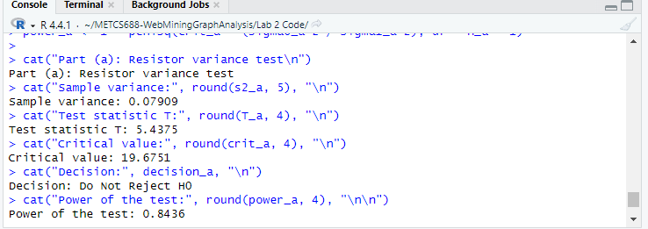
- A researcher aims to measure the shift in volatility in daily index returns. The mean return is normalized to 0 and the volatility is supposed to be 𝜎𝜎₀ = 0.01. The researcher however, suspects that the volatility is actually 0.02 and to test her hypothesis, she takes 30 samples. The calculated sample variance is 1.8 × 10⁻⁴. Does the data confirm her hunch?
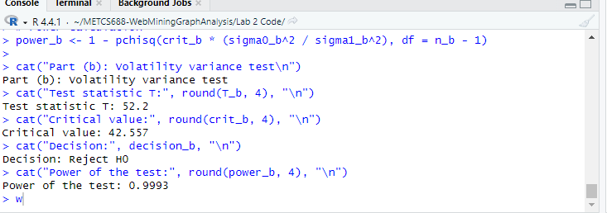
This supports the researcher’s hunch

- Recall the communication example discussed in class. In the context of the example, explain why 𝛼𝛼 and 𝛽𝛽
cannot be minimized to 0 simultaneously
The only way to reduce alpha is to raise the detection threshold, making the system more cautious and needing stronger evidence to say a message was sent. But if the threshold is too high, even real messages might not reach it, which increases beta (more missed detections)
On the other hand, to reduce beta, we lower the threshold so that even weak signals can trigger detection. This makes it easier to catch real messages but also increases alpha, because now noise (not actual messages) might be misinterpreted as a signal
This tradeoff exists because both types of error depend on the same threshold. Unless there is no overlap between the distributions of signal and noise (which is very rare in real-world settings), you always have to make a compromise. Reducing one error generally increases the other
So in short, alpha and beta cannot both be minimized to zero at the same time because of the overlap between noise and signal. Lowering one usually raises the other

